How to separate our program in another camera
We can use 2 types of cameras:
- USB camera (Normal webcam)
Connect it to your laptop/PC with USB
Change the camera index in your code ( Change 0 and write 1 or 2 )
EXAMPLE:
cv2.Videocapture(1)
- camera / CCTV camera
This camera gives a RTSP / HTTP link
We can put this link in python code
EXAMPLE:
cv2.Videocapture(“rtsp: / /username:password@camera-ip-address”)
If we want multiple cameras together:
We can do something like:
cam1 = cv2.Videocapture(0)
cam2 = cv2.Videocapture(1)
we can import our program in ESP32 CAM.
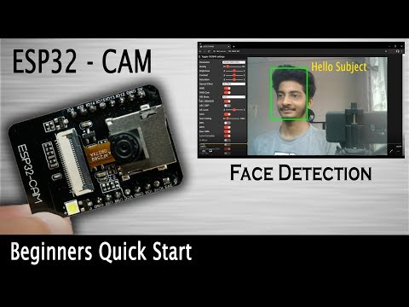
https://youtu.be/U7qbehy9aDo?si=XBvP8YgGmhwyI1xg

